Wallington Holiday Parade 2025

Wallington Fire Department, Civic Center, 24 Union Blvd., Wallington, NJ, 07057
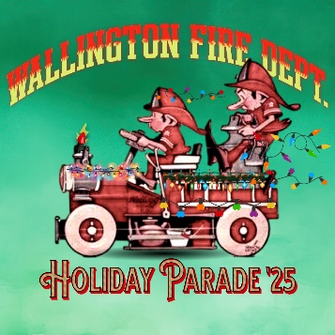
Registration 2025

SAT. NOV. 29, 2025 REGISTRATION & Staging: anytime - 5:00 pm
Please Note: Absolutely NO DRINKING on top of any Fire Apparatus during parade.
PARADE BEGINS: 6:00 PM SHARP!

ORGANIZATION _______________________________________________________

ORGAN. ADDRESS_____________________________________________________

___________________________________________________________________

PERSON IN CHARGE_________________________________________________________

EMAIL________________________________________________________________

REACHABLE Cell Phone # _____________________________________________

Total Number of Vehicles Attending:______________________________________

LIST THE TYPE OF VEHICLES ATTENDING: NOTE:“Lengths not needed”

___________________________________________________________
____________________________________________________________

_____________________________________________________________
Please complete as soon as possible or by the latest November 29, 2025
Or EMAIL TO: Richard.Pelcher@gmail.com Or WFDholidayparade@gmail.com
Or Mail to Above Address
Fax - (973) 779-4879

Wallington Fire Department’s Holiday Parade 2025
WAIVER and HOLD HARMLESS 2025

Please fill this Waiver in, Sign It, and Fax it to: (973) 779-4879, or Email to richard.pelcher@gmail.com , or regular mail

___________________________________________________________________________________

Print Your FD, Company, Organization, or Name

In Consideration of the acceptance by the Wallington Fire Dept. of the entry of the undersigned in the Wallington Fire Department’s
Holiday Parade to be held in the Borough of Wallington, NJ on
Sat. Nov. 29, 2025, the undersigned does hereby remise, release, and forever discharge the said Wallington Fire Dept., the Borough of Wallington, NJ and their officers, representatives, successors or assigns of and from all and any manner of actions, cause of actions, suits, debts, trespasses, damage and injuries, which may be sustained to equipment or personnel as a result of its participation in activities in conjunction with the Wallington Fire Dept. Holiday Parade in the Borough of Wallington, NJ on Sat. Nov. 29, 2025 and does hereby further covenant and agree to hold harmless and defend and to indemnify and keep indemnified the Wallington Fire Dept., the Borough of Wallington, NJ and their officers, representatives, successors, or assigns and to hold and save them harmless from and against all claims and damages whatsoever as result of said participation.

___________________________________________________________
Representative’s Signature

___________________________________________________________
Print Name and Title

___________________________________________________________
Date Wallington Fire Department’s Holiday Parade,
Civic Center, Union Blvd.
Wallington, NJ 07057
Emai: richard.pelcher@gmail.com
Fax (973) 779-4879

Drinking on top of a vehicle during parade will not be tolerated, and be cause for disqualification of any awards & possible prosecution by WPD

